All the fallowing steps are after creating GCP account and create a project

Download Google SDK file

Step1:



When you choose option “Y” it will try to login in to the browser with respective account



Step 2 :

Choose the your project here my project has a index 1

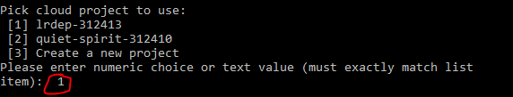

Step 3 : Change your directory to project directory here if u observe I am at C drive but my project is in Drive E drive

Note: Its mandatory to create “Yaml “ file in the yaml file we have to mention **runtime: python37**



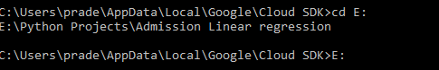

Then check the files by using command dir

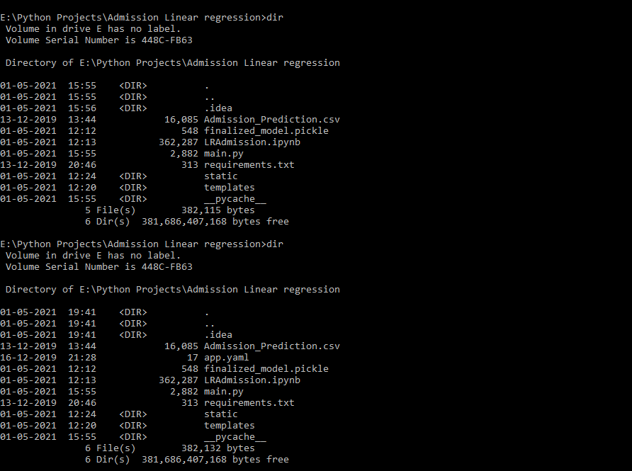

Step 5:

Now we need to deploy our model by fallowing command

gcloud app deploy app.yaml -- <Project name>





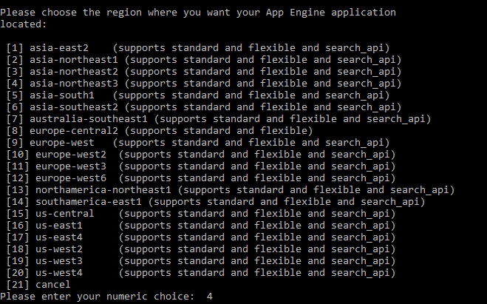

After this you will get an url

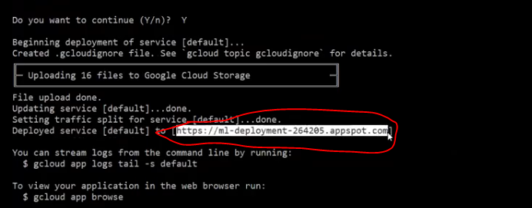

Step 6: Check the url in the browser

